DocuSign Digital Transaction Management Platform

Digital Transaction Management is delivering massive benefits to organizations of every size, industry, and geography, in three key areas:

* **Immediate financial gains** – By reducing the transaction time, organizations see needle-moving financial benefits in weeks rather than months or years.
* **Transforms the customer experience** – Instead of waiting days, week, or even months for transactions to be completed, progress can be made near instantly. This velocity delights external and internal customers and elevates the organization that provides the superior service.
* **Readily demonstrates compliance** – Every document has a readily accessible digital audit trail to making documenting compliance for industry laws and regulations fast and easy.

## Key benefits of using DocuSign

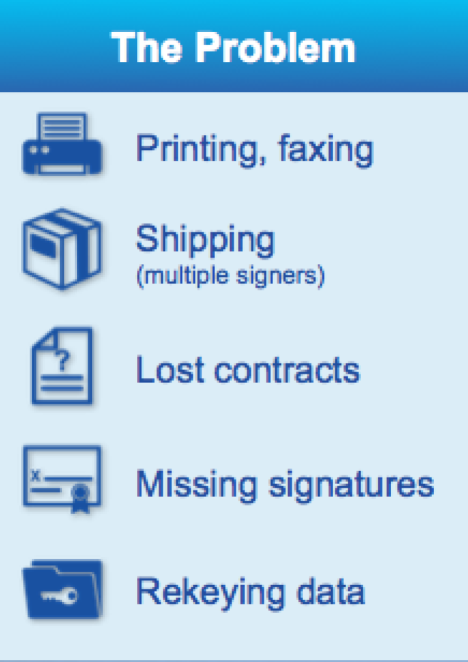 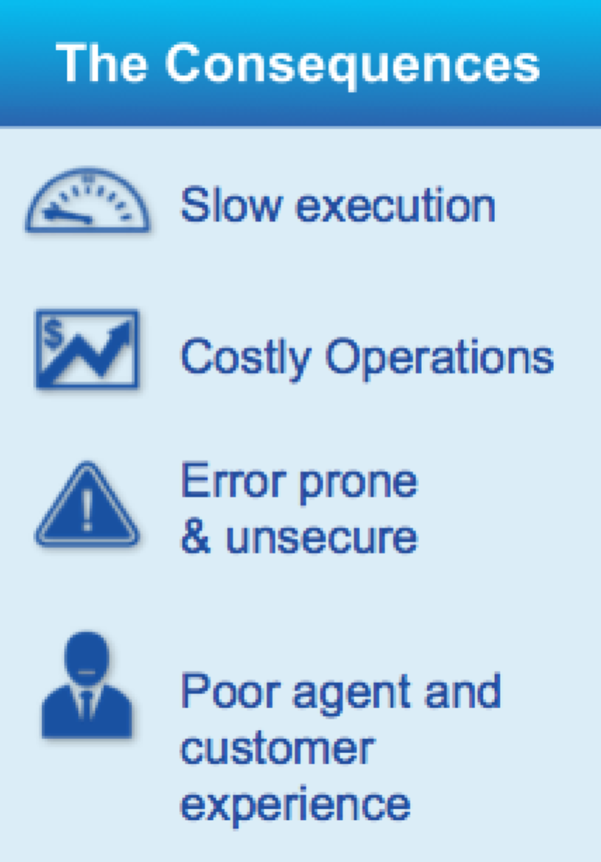 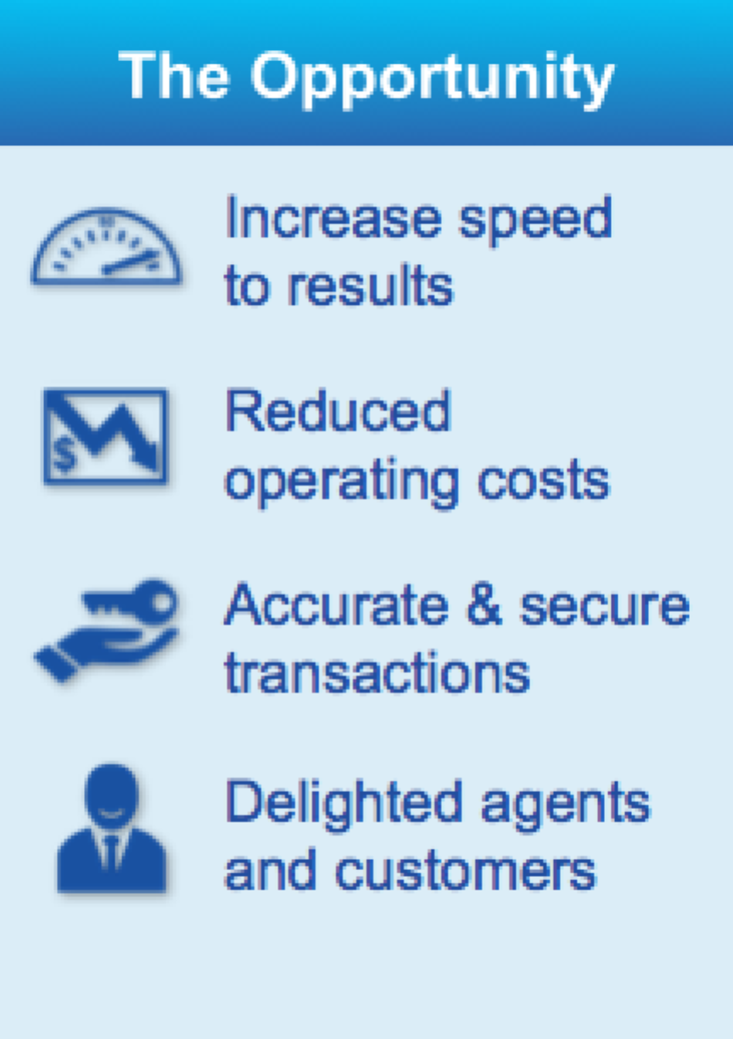

Try DocuSigning Today:

## /S1Sign/ /S1Initial/ /S1FullName/ /S1Date/

